**____________________________________________**

**COVID-19 pandemic and its regional economic impacts in Indonesia:**

**A spatial econometric approach**

Harry Agintaa · Ragdad Cani Mirantib · Carlos Mendezc

**Abstract**

The purpose of this study is twofold; first, to reveal spatial pattern of the coronavirus (COVID-19) infection across provinces in Indonesia and second, to investigate the impacts of the virus outbreak on regional economic growth. For these purposes, we define a spatial connectivity structure across the provinces of Indonesia. Applying spatial exploratory data technique on published data, we show how spatial connectivity alters COVID-19 spread over time from the spatial perspective. While results from appropriate spatial econometric model suggest the significance of spatial spillovers of “shocks” on provincial economic growth in the period of pandemic as opposed to non-significant spatial effect prior the pandemic.

Keywords COVID-19 · pandemic · regional · Indonesia

JEL Classifications C21 · O47 · R10 · R11

____________________________

a Graduate School of International Development, Nagoya University, JAPAN.

E-mail: [aginta.harry@c.mbox.nagoya-u.ac.jp](mailto:aginta.harry@c.mbox.nagoya-u.ac.jp)

b Graduate School of International Development, Nagoya University, JAPAN.

E-mail: [miranti.ragdad.cani@g.mbox.nagoya-u.ac.jp](mailto:miranti.ragdad.cani@g.mbox.nagoya-u.ac.jp)

c Graduate School of International Development, Nagoya University, JAPAN.

E-mail: [carlos@gsid.nagoya-u.ac.jp](mailto:carlos@gsid.nagoya-u.ac.jp)

**Introduction**

Firstly detected in Wuhan, China in December 2019, the outbreak of novel coronavirus COVID-19 has attracted worldwide attention. According to World Health Organization (WHO), the first detected case outside of China was reported in Thailand on 13 January 2020 (WHO, 2020a). Thereafter, the number of infected people around the world started to show an explosive trend. Referring to the Situation Report of WHO, by the end of January 2020, the disease had infected 9,826 people globally, where 106 people were situated in 19 countries outside China (WHO, 2020b). By the end of June 2020, the same report had announced more than 10 million confirmed cases and more than 500,000 deaths (WHO, 2020c).

To limit the massive spread of the virus, more than 100 countries worldwide had implemented lockdown by the end of March 2020, either a full or partial lockdown (BBC, 2020). As lockdown policy massively instituted around the world, people’s activities had been greatly reduced, including economic and business. Several ideas explain how the pandemic may affect economic activities. A report from Asian Development Bank (ADB, 2020) mentions that COVID-19 outbreak will negatively affect economic activity via multiple channels: a sharp decline in domestic consumption, and possibly investment if views on future business activity is affected; shrinking in tourism and business travel; cross-sector and cross-country spillovers from slowing demand through trade and production linkages; supply-side disruptions to production and trade; and effects on health such as increased disease and mortality as well as shifts in health care spending.

Economists acknowledge these multiple channels of how COVID-19 pandemic reduce economic activities as so-called ‘supply’ and ‘demand’ shocks (Baldwin and Weder di Mauro, 2020). Hausmann (2020) argues the economic impact of COVID-19 is mainly in the forms of negative supply shock stemming from reduction in production capacity. When workers are infected, firms have to limit the contact between workers and if needed, stop the production temporarily. Inoue and Todo (2020) estimate that shutting down firms in Tokyo would result in an 86% reduction in output throughout Japan within one month. If the situation lasts for more than what expected, the supply shock would most likely lead to a demand shock (del Rio-Chanona et al., 2020; Guerrieri et al., 2020). On the other hand, the implementation of mitigation measures such as social distancing by governments and public health authorities in many countries has also led consumers to reduce their consumption, in particular on various services involving frequent physical contact such as restaurants, airlines, and tourism. As the workers in these sectors face significant income reduction due to lower sales, their spending on other goods and services would also decrease, leading to a shrinking in demand for goods and services across many economic sectors (Gourinchas, 2020). Furthermore, the pandemic has also increased uncertainty on future economic prospects. This eventually causes greater negative demand shock stemming from diminished consumption on durable goods and investment.

Since the pandemic is happening across the globe these‘supply’ and ‘demand’ shocks will put the globalyat risksince the negative economic impact of the pandemic is spreading Taking into account these potential devastating impacts of COVID-19 on economy, in its World Economic Outlook (WEO) Update, June 2020, the International Monetary Fund (IMF, 2020) mentions that global growth in 2020 is projected at –4.9%, 1.9 percentage points below its April forecast, indicating that the pandemic has had a more negative impact on activity in the first half of 2020 than anticipated.

Reviewer 1 (R1): The authors may also discuss the demand shock due to limitation of people movement (physical distancing)

Response: The discussion on the demand shock has been added.

In Indonesia, the first COVID-19 infection was announced in early March 2020. As of 1 July 2020, the number of confirmed infected people in the country had reached close to 57,770, with 2,934 deaths (WHO 2020d). Worse still, it is predicted that total confirmed deaths in Indonesia by 1 November 2020 would reach more than 12,800 (covid19-projections.com 2020). Like elsewhere in the world, the economic impact of COVID-19 in Indonesia is huge. The government’s latest 2020 Gross Domestic Product (GDP) forecast is a range between 1.1% contraction to 0.2% growth, down from 2019’s 5% expansion, due to the fallout of the coronavirus pandemic (https://jp.reuters.com/article/indonesia-politics-economy-gdp-idUSJ9N2C2033). (source?). A double hit scenario proposed by the OECD (OECD 2020) projects that the Indonesian economic growth rate could contract to –3.8%.

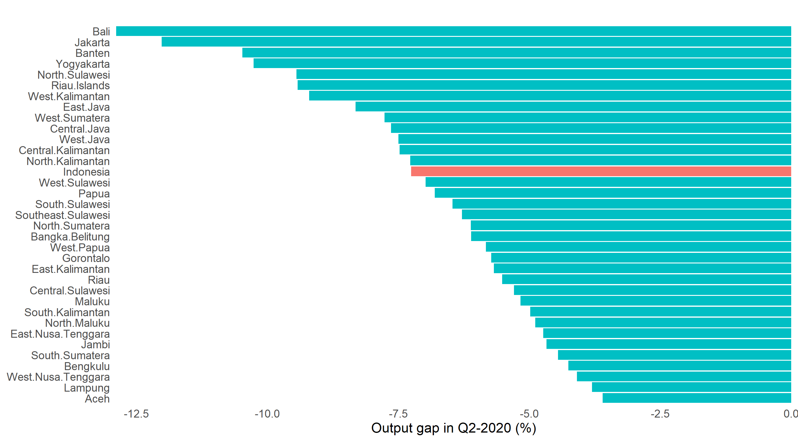

Figure 1. GDP loss in Q2-2020 measured by output gap

The slowing economic activities in Indonesia has been reflected in the 2020 first semester economic performance. Figure 1 shows the impact of COVID-19 outbreak on national and regional GDP in Indonesia during Q2-2020, measured in output gap.[1] At the national level, the pandemic had trimmed economic capacity by around 7.5% (see the red bar in Figure 1). (R1: put citation or reference over here). In other words, under the implementation of large-scale social restrictions policy (Pembatasan Sosial Berskala Besar - PSBB) in many regions, the nation’s economy worked around 92.5% of its capacity. At the provincial level, all provinces exhibited negative output gap, reflecting the depletion in economic capacity. Tourism and services driven regions like Bali, Jakarta and Banten are provinces with the highest negative output gap (see the first three top bars in Figure 1). (R1: adding citation).

Just like cross-country economic spillover that is inevitable, within-country spillovers is also expected. Even more, since regions within a country has more similarities compared to a cross-country situation, the spillover effect is expected to be more prevalent.

(But you have mentioned why it is important to analyze the impacts of the spatial growth across provinces in Indonesia)

Therefore, this paper attempts to analyze how the pandemic affects the spatial growth across provinces in Indonesia. In the absence of adequate number of similar studies available so far, the facts and results revealed in this paper would help to bring new insights in understanding how the transmission of COVID-19 infection is linked to the geographical proximity, and how Indonesian regional economy is affected by the pandemic.

Before estimating the growth spillover, in the first part of the paper we conduct exploratory spatial data analysis (ESDA) for the COVID-19 infection cases. Our exploration indicates the link between spatial connectivity and the spread of the virus. This is particularly seen in Java region, mainly between Jakarta, West Java and Central Java, the three neighboring provinces. Regarding to the spatial spillover of economic growth impacts of COVID-19, the results from spatial econometric models show that the provincial growth in the pandemic period is affected by the spillover of shocks in the surrounding regions.

The rest of this paper is organized as follows. The second section exposes some recent development on COVID-19 cases in Indonesian regions and the latest figure of regional economic growth. In Section 3 we discuss data and methodology. Section 4 presents the results and discussion, and finally Section 5 concludes the paper.

**THE PANDEMIC AND REGIONAL ECONOMIC PERFORMANCE IN Q2-2020**

Before formally analyzing the impacts of COVID-19 cases on regional economic growth, it is necessary to document some recent development on the number of COVID-19 cases and economic indicators across Indonesian provinces. Figure 2 describes the evolution of COVID-19 cases in Indonesia since its first identified case in March 2020 until the end of June 2020.

Next, in Figure 3 we present the charts of COVID-19 cases and the selected economic variables across provinces in 2020-Q2. This is useful to understand how the pandemic affects economic activities contemporaneously. Panel (a) plots the change in number of COVID-19 cumulative cases (per 100,000 population) from March to June 2020. The highest increase of number of cases is recorded in Jakarta, the capital of Indonesia (100.3), followed by South Kalimantan (72.9), and North Maluku (56.85), while Aceh province records the lowest increase in number of cases per 100,000 population (we computed the change in number of COVID-19 cumulative cases based on the daily data available at https:// kawalCOVID19.id. (R1: sources of data).

As seen in panel (b), most of provinces (32 out of 34) recorded negative growth in Q2-2020 (yoy, %), where provinces in Java-Bali region are the worst performers. The economic growth of Bali, Jakarta, Banten provinces are -10.98%, -8.22%, and -7.4% (year-on-year) respectively. On the other hand, two easternmost provinces, West Papua and Papua, were able to maintain positive economic growth of 0.53% and 4.52% respectively. We also utilize the COVID-19 Community Mobility Index from Google to capture the effects of pandemic on people mobility. From panel (c), it can be seen that Bali, Maluku and Jakarta are the provinces where mobility reduced the most relative to the baseline.[2] Lastly, we also document the number of people who lose their jobs as the impacts of COVID-19 pandemic, plotted in panel (d). Similar to the impacts on economic growth, provinces in the Java region report the highest number of people who had lost their jobs due to pandemic. West Java province suffers the most with around 340,000 people reporting lost their jobs from March to June 2020. Next, Jakarta, Central Java and East Java are the other provinces that record high numbers of jobs losses during the same period (we received the data from the Ministry of Manpower). (R1: sources of data).

|  |
| --- |
| (a) Change in number of cases |

|  |
| --- |
| (b) GDP growth in Q2-2020 |
| (c) Change in people’s mobility |

|  |
| --- |
| (d) Number of people who lose jobs |

Figure 2. COVID-19 cases and the development of some main economic variables



(R1: source of data?)

Next, in Figure 3 we show the correlation among the indicators plotted in Figure 2.[3] Several interesting points can be highlighted. First, people’s mobility is significantly having negative correlation with the change in number of COVID-19 cases and the share of TAS (Transportation, Accommodation and Services) in GDP. This means that mobility decreases at the larger rate in provinces with higher COVID-19 cases and TAS share in GDP. Second, GDP growth is more connected to number of jobs loss and TAS share in GDP. Third, in addition to people’s mobility, the change in number of COVID-19 cases is also significantly correlated with the share of TAS in GDP. Overall, the plot is useful to explain how the current state in one variable is affecting the others. In particular, the current condition of economic structure has significant correlation with three out of four other variables; it is negatively correlated both with GDP growth and people’s mobility while has positive correlation with the change in number of cases. Since the number of infected people is higher in provinces with higher TAS share in GDP (the positive correlation), local governments implemented large-scale social restrictions (PSBB) policy to minimize contacts among people, such as schools’ closure, work-from-home, restrictions on religious congregations and even closing of houses of worship. As the results, people’s mobility decreased, and the reduction in people’s mobility decelerates economic activities (this explains the negative correlation).[4]

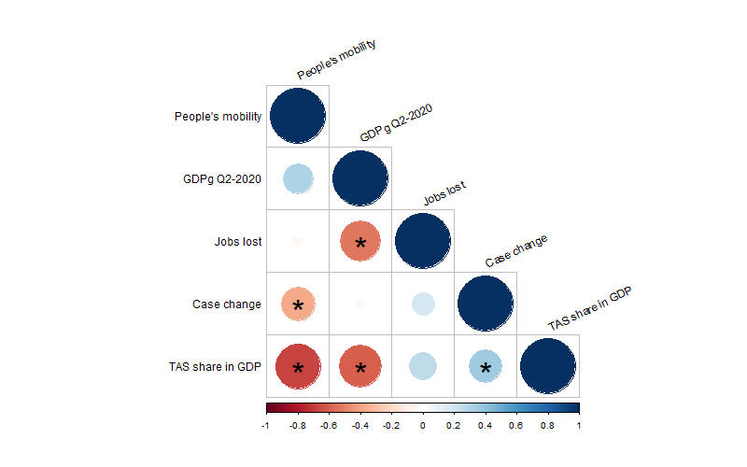

Figure 3. Correlation between selected variables. Significant correlation at 5% is marked with star.

(Content of this section is not that clear at the moment. Probably best to describe (historically) the spread of the pandemic across provinces in Indonesia. So a snap as this is not useful.)

Check and review also several regulation re COVID and people movement:

https://covid19.go.id/p/regulasi

**LITERATURE REVIEW**

R1: The literature discussing spillover between provinces is not available. In addition, the discussion on the economics shock on regional growth is also not available.

Note that there are literature on spatial regional correlation in Indonesia before. Several are in previous IRSA Book:

<https://www.dropbox.com/s/g3hg254dyr1gujt/Chapter_13_2011.pdf?dl=0>

https://www.dropbox.com/s/2e588dmxompb0ny/Chapter_5_2009.pdf?dl=0

Or from other resources. For example:

<https://www.anzrsai.org/assets/Uploads/PublicationChapter/Vidyattama-2014-2.pdf>

<https://www.tandfonline.com/doi/full/10.1080/19475683.2013.806353>

<https://link.springer.com/article/10.1007/s10109-005-0016-3>

**Data and Methodology**

We use data available in https:// kawalCOVID19.id. This data is used to evaluate the spatial dependence of COVID-19 infection cases across Indonesian provinces. The original data contains daily cumulative cases in 34 provinces. We transformed the daily data into a ratio of monthly cumulative case per 100.000 population and used it as the final data.

We used quarterly provincial real GDP data published by Indonesian Central Statistics Bureau to capture real economic variable.[5] The final form of GDP data used is the annual GDP growth rate (yoy, %). We utilize this dataset to estimate the spatial dependence of economic impacts of COVID-19 across provinces. The summary statistics of our regression variables is presented in Table 1.

Table 1. Summary Statistics of GDP and GDP growth rate in both periods

|  |  |  |  |  |  |  |  |
| --- | --- | --- | --- | --- | --- | --- | --- |
| Variables | Mean | Std.Dev | Min | 25% | Median | 75% | Max |
| GDP 2015:Q1 | 64300000 | 90900000 | 4922250 | 15064409 | 27500000 | 60660602 | 351000000 |
| GDP 2019:Q4 | 83100000 | 119000000 | 6869000 | 20608658 | 34600000 | 81776676 | 471000000 |
| GDP 2019:Q1 | 78500000 | 113000000 | 6473000 | 17330444 | 31400000 | 81776676 | 446000000 |
| GDP 2020:Q2 | 76400000 | 108000000 | 6581357 | 17860654 | 32300000 | 79259316 | 415000000 |
| GDP Growth 2015:Q1 - 2019:Q4 | 0.014 | 0.004 | 0.006 | 0.012 | 0.013 | 0.303 | 0.03 |
| (without pandemic period) |  |  |  |  |  |  |  |
| GDP Growth 2019:Q1 - 2020:Q2 | 0.001 | 0.012 | -0.014 | -0.004 | 0.001 | 0.030 | 0.005 |
| (with pandemic period) |  |  |  |  |  |  |  |

Note: GDP value on the table above is in Million (Rupiahs)

To carry out a spatial analysis, we first define a spatial connectivity structure across the provinces of Indonesia. In the literature, there are multiple criteria to define that structure. The most popular are spatial contiguity, spatial distance, and k-nearest neighbors. In this paper, we implement a generalized version of spatial contiguity based on the estimation of Thiessen polygons (Anselin and Rey, 2014). We use GIS data to define the centroid of each province and construct the Thiessen polygons accordingly as shown in Figure …. of Appendix. From the estimated polygons, we estimate spatial connectivity based on the contiguity in the polygon of provinces (see Figure … of Appendix). Specifically, two polygons (or provinces) are neighbors when they share a common border or an edge. The estimation of Thiessen polygons allows us to define a spatial connectivity structure based on individual areas of influence around geographical locations. R1: What kind of data employed to capture the connectivity across regions, please explain.

To facilitate visual interpretation, Figure 4 shows the overlap between the estimated connectivity structure and the provincial map of Indonesia.

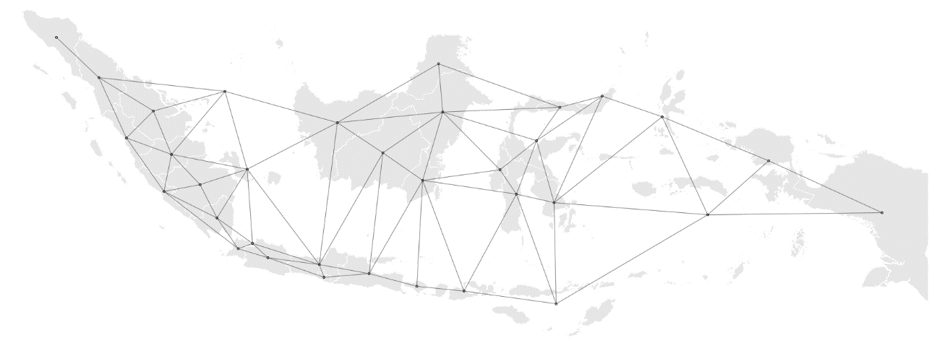

Figure 4. Spatial connectivity structure of the provinces of Indonesia

In the first part of the analysis, we explore the spatial dependence in COVID-19 cases across provinces. In the context of the previously estimated connectivity structure, an exploratory spatial data analysis provides a first evaluation of the nature of spatial dependence that is observed in the data. An analysis of spatial dependence combines the notion of attribute similarity with locational similarity. That is, measuring to what extend the neighbors of a region show similar or dissimilar patterns in the attribute being studied.

Anselin (1995) proposes way to visualize the strength and type of local spatial dependence. He uses a scatter plot to study the relationship between an attribute of a region (*x*) and the weighted average of its neighbors (**W***x*). The neighbors of every region are identified based on the previously estimated connectivity structure, which is operationalized as a weights matrix (**W**). The quadrants of the scatter plot classify the regions as hot spots (relatively high values), cold spots (relatively low values), and spatial outliers (high values surrounded by low values and vice-versa).

A local indicator of spatial association (LISA), *Ii* , is computed for each region as follows:

|  |  |
| --- | --- |
|  | (1) |

where is a spatial weight that is derived from the spatial structure **W**, is the variable under study measured in region *i*, is the same variable measured in region *j*, and is the average of *x*. Following Anselin et al. (2007), statistical inference is based on a conditional permutation approach.

In the second step of this paper, we examine the regional growth impacts of COVID-19 pandemic by applying spatial regression framework. Basically, spatial analysis is about accounting for spillover effects derived from spatial dependence between regions. Spatial autoregressive models broaden the ordinary linear regression through permitting dependent variables in one area to be affected by dependent variables in neighboring areas, covariates from neighboring areas, and errors from neighboring areas. Anselin (1988) has firstly introduced two common models to recognize spatial dependence through spatial autoregressive models, which are Spatial Lag Model (SLM) and Spatial Error Model (SEM). It commonly consists of spatial lag model and the spatial error model. Fingleton and Lopez-Bazo (2006) also confirms that spatial dependence among growth processes of sub-national level may be caused by two types of features. The first feature is correlated with random shocks, symbolized by spatial error models, coming from neighboring regions and another one is correlated with the growth rates of neighboring regions, symbolized by spatial lag models. Lesage and Fischer (2008) also concerned attention to the issue of spatial dependence in growth regressions. The issue may come due to pecuniary externalities from neighbouring regions (captured by spatial lag) or spatial autocorrelation among regression residuals (captured by spatial errors). If this issue is uncovered, it will lead to inconsistent and bias estimation because correlation between spatially lagged dependent variable ends up in model generating parameter estimates smaller or larger than the true model.



Taking the standard growth regression of Solow without augmenting with human capital and physical capital as (Mankiw. et.al, 1992) as the starting point, we follow the seminal works of Rey and Montouri (1999) by involving the role of spatial dependence across regions. The purpose of the inclusion of spatial dependence is to give intuitive comprehension that interactions among geographical neighbors can affect the outcome of the entire regional system. If those interactions are not included in Equation 2, and they are reflected as spatial dependence in the error term, then the estimates of Equation 2 can be misleading. Unaccounted spatial dependence can lead to biased or inefficient estimates of the convergence indicators.

Two most prominent specifications used in the spatial regression literature are SLM and SEM. In our analysis, we implement the cross-sectional spatial regression model. In the SLM specification, spatial dependence exhibits the actual interaction among spatial units that take place through the dependent variable. In this context, our SLM specification is as follows,

|  |  |
| --- | --- |
|  | (2) |

where **W** is the spatial weights matrix that represents the spatial structure of the data, is the spatial lag of the dependent variable, is spatial lag coefficient, is the average growth rate of the GDPduring T period (quarters) , is value of the GDP in the base (initial) year, which are Q2015:1 for the model without pandemic period and Q2019:1 for the model including pandemic period and is error term.

In the SEM specification, on the other hand, spatial dependence could represent a missing variable that embodies a spatial structure. In this context, our SEM specification is written as follows,

|  |  |
| --- | --- |
|  | (3) |

where I is a vector of ones, **W** is the spatial weights matrix, and *λ* is a spatial error coefficient.

Both spatial models are estimated through maximum likelihood estimation. To choose the best model, the measures that commonly used are through R-square, Log-Likelihood, Akaike information criterion (AIC) and Bayesian Information Criterion (BIC). In this paper, the model selection is based on Akaike information criterion (AIC) as well as the Bayesian Information Criterion (BIC). Based on those indicators, the model with the smallest value of AIC and BIC is the fittest.

**Results and discussion**

As explained before , the LISA statistic indicates the presence or absence of significant spatial clusters and/or outliers for each location (Anselin, 1995). Statistically significant spatial clusters contain a group of regions with relatively high values (high-high or hot spots) and relatively low values (low-low or cold spots).[6] Differently, the significant spatial outliers (high–low and low–high regions) reflect spatial anomalies, and therefore are the actual locations of interest.

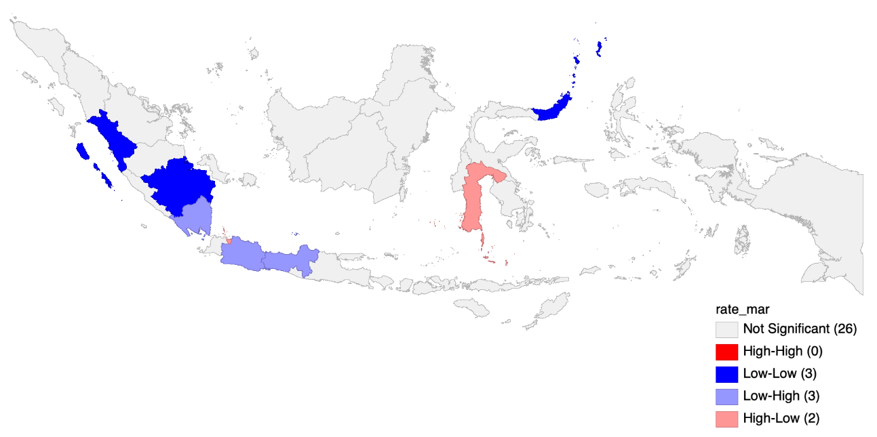

Fig. 7: Local spatial dependence in March 2020

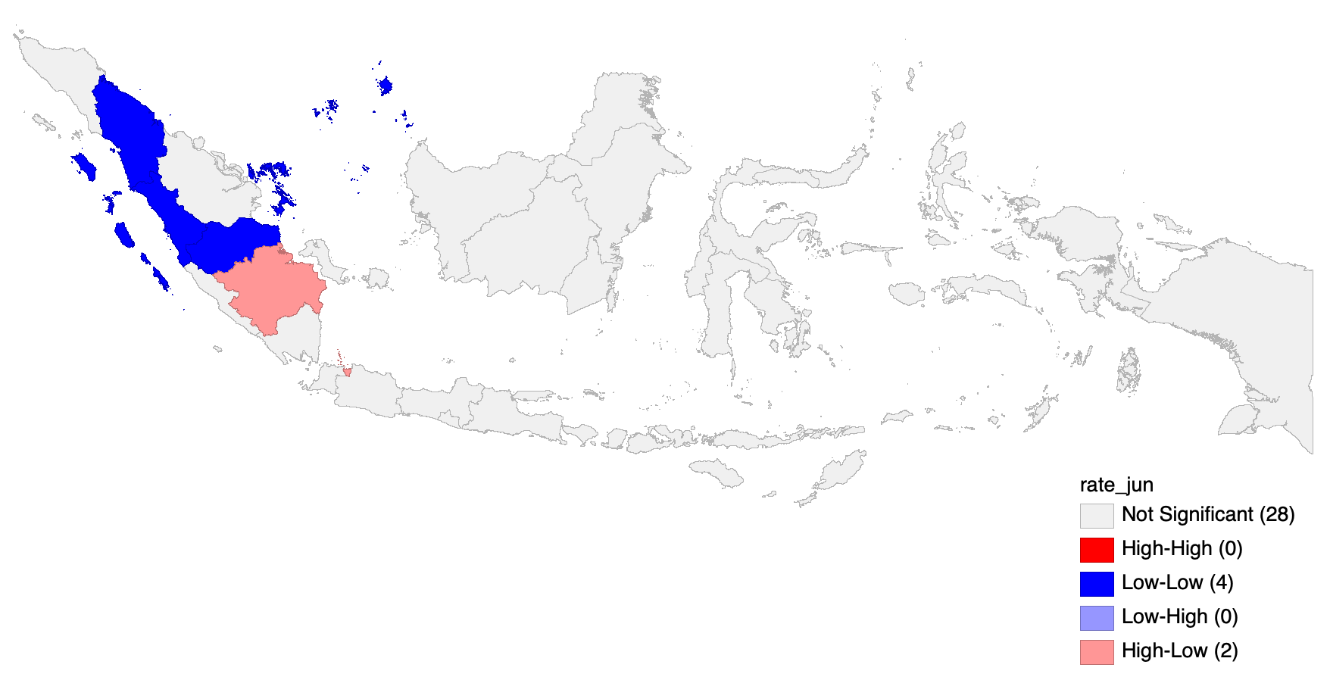

Fig. 8: Local spatial dependence in June 2020

The LISA cluster maps of the number of COVID-19 infection cases are given in Figure 7 and 8 for March and June 2020 period respectively. By the end of March - the first month of COVID-19 case detected in Indonesia - there were three provinces in low-low cluster (West Sumatra, South Sumatra and North Sulawesi), three provinces in low-high cluster (Lampung, West Java, and Central Java), two provinces in high-low cluster (Jakarta and South Sulawesi), and none of provinces in high-high cluster. The spread of COVID-19 in provinces in Sumatra island were relatively low. Meanwhile, the presence of spatial outliers of high-low cluster and low-high cluster in Java island (the most populated island) is particularly interesting. The first COVID-19 case in Indonesia was detected in Depok District, West Java province in March 2, 2020.[7] However, during the month, the number of cases in Jakarta (the capital city and located next to West Java) rose significantly higher than that in West Java. This may reflect the two following possibilities; first, the massive COVID-19 testing in Jakarta and second, the strong connectivity between these two provinces where most of people who live in West Java work in Jakarta.

In June, however, provinces previously in low-high cluster in Java island were no longer present. This is because the increased rate of COVID-19 infection in these provinces (West Java and Central Java) during the period. Interestingly, Jakarta remained in high-high cluster, marking the capital city as the epicenter of COVID-19 cases in the country. Possibly, the missing low-high cluster in Java island reflects the contagion from Jakarta. This is particularly true during the period of Ramadan followed by Eid al-Fitr where people traveled to their home town to meet relatives. In Sumatra, an increased infection case from April to June 2020 has moved South Sumatra province from low-low to high-low cluster. Meanwhile, four provinces located near South Sumatra were in low-low cluster (North Sumatra, West Sumatra, Riau Islands and Jambi). Reflecting the transition pattern observed in Java island from March to June, it is important to anticipate the contagion from South Sumatra to neighboring provinces.

4.2 How COVID-19 pandemic affects regional growth dynamics?

This section presents the main findings of spatial autoregressive models in evaluating how the pandemic affects the spillovers of economic growth across provinces. To be more precise, we measure how the growth in a province is affected by the growth in surrounding regions. Ideally, in our equation we should consider all necessary growth determinants explained in the standard Solow growth model featuring the Cobb-Douglas production function (Islam, 1995). However, due to data availability and time constraint, we use initial economic condition (log of GDP in 2015:Q1) for the model without pandemic period and log of GDP in 2019:Q1 as the proxy of growth determinants, where the economy is assumed to be in its natural condition. Thus, our models capture the spatial effects of economic growth by controlling the natural level of main growth determinants. To understand the impacts of the pandemic, the models are estimated for two different time span; from 2015:Q1 to 2019:Q4 and from 2019:Q1 to 2020:Q2. For simplicity, the first period is called pre-pandemic period and the latter is referred to with pandemic period.

One important assumption in spatial autoregressive model is the existence of spatial dependence in residuals. Thus, before estimating the spatial autoregressive model, we conducted spatial dependence test by applying Moran’s I test. Table 2 presents the results of the test between two periods; pre-pandemic period (Column 2) and with pandemic period (Column 3). The result from Moran’s I test suggests to accept the hypothesis that residuals in both periods are independent and identically distributed (i.i.d.). This indicates that the residual factors in the economic growth equation are spatially independent during COVID-19 period in both periods, implying the inexistence of spatial autocorrelation among residuals in both models. However, since our spatial autocorrelation analysis through Moran’s I statistics and LISA cluster map suggest that the existence of significant spatial dependence of our variables among regions, the importance of including spatial variable in the model, in this case, spatial lag and spatial error, could be considered in our analysis.

Table 2. Spatial dependence test in the residuals

|  |  |  |  |  |
| --- | --- | --- | --- | --- |
| Variables | GDP growth rate | | GDP growth rate | |
| 2015:Q1 - 2019:Q4 | | 2019:Q1 - 2020:Q2 | |
| (Without  pandemic period) | | (With pandemic period) | |
| Number of observations | 34 |  | 34 |  |
| Moran's I Test | 1.48 |  | 0.00 |  |
| p-value | 0.22 |  | 0.99 |  |
| Notes: Robust standard error in parentheses. |  |  |  |  |
| *** *p* < 0.01, ** *p* < 0.05, * *p* < 0.1 |  |  |  |  |

Table 3 presents the results of spatial and non-spatial regressions of the GDP growth in pre-pandemic period and with pandemic period. All spatial regressions are estimated using maximum likelihood estimator for cross-sectional data. The table shows that both coefficient in OLS and SLM model are significant in pre-pandemic period, while only coefficient in SEM model is significant in the with pandemic period. In terms of spatial autocorrelation coefficient, which are spatial lag and spatial error coefficient, although they are not statistically significant and relatively small, they still imply the existence of spatially correlated dependent variable and error among provinces.

To be more specific, to estimate the effect of initial economic size to the economic growth in pre-pandemic period, firstly we should define our best specification model. The two significant models, OLS and SLM tend to generate similar coefficient of economic size. Comparing the two indicators of goodness of fit test, OLS model appears to be the fittest with the smallest AIC and BIC in the pre-pandemic period. It is also supported by the insignificant spatial lag coefficient in our spatial regression model, indicating that the estimation process without including spatial effect would not lead to generate the bias parameter. Thus, in the normal condition, the negative coefficient on the log of GDP in 2015:Q1 suggest that larger economies are affected worse from growth reduction.

Table 3. Non-spatial and spatial regression of with and without inclusion of pandemic period

|  |  |  |  |  |  |  |
| --- | --- | --- | --- | --- | --- | --- |
|  | Without pandemic period | | | With pandemic period | | |
| Variables | Dependent Variable: GDP Growth of 2015:Q1 - 2019:Q4 | | | Dependent Variable: GDP Growth of 2019:Q1 - 2020:Q2 | | |
|  | OLS | SLM | SEM | OLS | SLM | SEM |
| Log of GDP in 2015Q1 | -0.022** | -0.022*** | -0.026 | -0.005 | -0.005 | -0.006** |
|  | (0.01) | (0.012) | (0.013) | (0.010) | (0.011) | (0.011) |
| Log of GDP in 2019Q1 |  |  |  |  |  |  |
|  |  |  |  |  |  |  |
| Spatial Lag Coefficient |  | 0.253 |  |  | 0.018 |  |
|  |  | (0.235) |  |  | (0.264) |  |
| Spatial Error Coefficient |  |  | 0.318 |  |  | -0.004 |
|  |  |  | (0.235) |  |  | (0.278) |
| Constant | 0.660* | 0.586* | 0.721* | 0.100 | 0.098 | 0.101 |
|  | (0.169) | (0.216) | (0.223) | (0.167) | (0.184) | (0.189) |
| Model selection/information criteria | | | | | | |
| AIC | -70.570 | -67.653 | -68.206 | -81.104 | -77.109 | -77.105 |
| BIC | -67.518 | -61.548 | -62.100 | -78.052 | -71.004 | -70.999 |
| Notes: Robust standard error in parentheses. | |  |  |  |  |  |
| *** *p* < 0.01, ** *p* < 0.05, * *p* < 0.1 |  |  |  |  |  |  |

Then, the results of spatial and non-spatial regressions of the economic growth in including pandemic period, where it evaluates the effect of including COVID-19 pandemic period to the regional growth dynamics. All coefficients reported in Table 3 show negative sign. However, only coefficient in SEM model is statistically significant. This significant and negative coefficient indicates that the regression residuals of a province is related to the regression residuals of neighboring provinces. The negative and significant coefficient on the log of GDP in 2019:Q1 implies that larger economies suffer more from growth declining when we include pandemic period in our period of observation. Since most of provinces with high GDP are located in Java-Bali region, the slump in economic growth during pandemic period is relatively larger in this region.

As mentioned earlier, the spatial error model assumes that the error term of province i depends on the error term of neighboring provinces on the basis of spatial weight matrix. In other words, significant spatial error coefficient reported Table 3 shows that the decline of growth in including pandemic period is affected by both province-specific shocks and other ‘spill-over’ shocks from neighboring provinces. Practically, the negative coefficient suggests that the increase of shocks of the neighboring regions tend to decrease the economic growth of a particular province.

Finally, as suggested by LeSage and Pace (2009), the estimated coefficient of SLM and SEM specification can be decomposed into direct and indirect effects to show the contribution of spatial spillovers. However, in the spatial error model, spatially correlated errors do not induce spillover effects in the covariates. Therefore, the results from this exercise lead to further research avenue to formally specify the ”shocks” (other variables unexplained in this study) and then measure their impacts on regional growth dynamics.

**Conclusion**

This study aims to reveal spatial pattern of the coronavirus (COVID-19) infection across provinces in Indonesia and to investigate the impacts of the virus outbreak on regional economic growth dynamics. Our exploratory analysis exposes the link between spatial connectivity and the spread of the virus, particularly in Java region, mainly between Jakarta, West Java and Central Java, the three neighboring and closely connected provinces. From the spatial analysis, our evaluation suggests that spatial dependence in regional growth dynamics does present in pandemic period. Thus, failure to control for spatial dependence in analyzing regional growth could be inappropriate. Furthermore, the results from spatial econometric models show that the provincial growth in the pandemic period is affected by the spillover of shocks in the surrounding regions.

As common in other spatial studies, we acknowledge the limitation of this study could include two following issues. First, the specification of weight matrix using contiguity of the estimated Thiessen polygons. Since there is no a single solid method that identifies a unique weight matrix reflecting the connectivity between locations, it is useful to test the models with alternative weight matrix. Second, given the availability issue and time constraints, the data used in the models is very limited to explain the complex regional growth dynamics. Therefore, future studies should incorporate more variables, including the institutional determinants of growth at a province level to obtain reliable estimates.

**References**

ADB (2020). The Economic Impact of the COVID-19 Outbreak on Developing Asia. Asian Development Bank. [https://www.adb.org/sites/default/files/publication/571536/adb-brief-128-conomic-impact-COVID19-developing-asia.pdf](https://www.adb.org/sites/default/files/publication/571536/adb-brief-128-conomic-impact-covid19-developing-asia.pdf). Accessed: 2020-08-28.

Anselin, L. (1988). Spatial Econometrics: Methods and Models. Kluwer Academic Publisher, Dordrecht, Netherlands.

Anselin, L. (1995). Local indicators of spatial association—LISA. Geographical Analysis, 27(2):93–

115.

Anselin, L., Sridharan, S., and Gholston, S. (2007). Using exploratory spatial data analysis to leverage social indicator databases: The discovery of interesting patterns. Social Indicators Research, 82(2):287–309.

Anselin, L., and Sergio J. Rey. (2014). Modern Spatial Econometrics in Practice, a Guide to Geoda, Geodaspace and Pysal. Chicago, IL: GeoDa Press.

Baldwin, R and B Weder di Mauro (2020), Economics in the time of COVID-19: A new eBook, VoxEU.org, 6 March.

BBC (2020). Coronavirus: The world in lockdown in maps and charts. <https://www.bbc.com/news/world-52103747>. Accessed: 2020-08-25.

COVID19 projections.com (2020). COVID-19 Projections Using Machine Learning. [https://COVID19-projections.com/indonesia](https://covid19-projections.com/indonesia). Accessed: 2020-08-28.

del Rio-Chanona, R. M., Mealy, P., Pichler, A., Lafond, F., and Farmer, D. (2020). Supply and demand shocks in the COVID-19 pandemic: An industry and occupation perspective. arXiv preprint arXiv:2004.06759.

Fingleton, B. (1999). Estimates of time to economic convergence: an analysis of regions of the European Union. International Regional Science Review, 22(1):5–34.

Fingleton, B. and Lopez-Bazo, E. (2006). Empirical growth models with spatial effects. ´ Papers in Regional Science, 85(2):177–198.

Gourinchas, P O (2020), “Flattening the pandemic and recession curves”, VoxEU.org, 3 June.

Guerrieri, V., Lorenzoni, G., Straub, L., and Werning, I. (2020). Macroeconomic implications of COVID-19: Can negative supply shocks cause demand shortages? Technical report, National Bureau of Economic Research.

Hausmann, R. (2020). Flattening the COVID-19 Curve in Developing Countries. Project Syndicate. [https://www.project-syndicate.org/commentary/flattening-COVID19-curve-in-developing-countries-by-ricardo-hausmann-2020-03](https://www.project-syndicate.org/commentary/flattening-covid19-curve-in-developing-countries-by-ricardo-hausmann-2020-03). Accessed: 2020-04-28.

IMF (2020). World Economic Outlook Update, June 2020. A Crisis Like No Other, An Uncertain Recovery. International Monetary Fund. <https://www.imf.org/en/Publications/WEO/Issues/2020/06/24/WEOUpdateJune2020>. Accessed: 2020-08-28.

Inoue, H. and Todo, Y. (2020). The propagation of the economic impact through supply chains: The case of a mega-city lockdown against the spread of COVID-19. Available at SSRN 3564898.

Islam, N. (1995). Growth empirics: A panel data approach. The quarterly journal of economics, 110(4):1127–1170.

LeSage, J. and Pace, K. (2009). Introduction to Spatial Econometrics. Chapman & Hall/CRC, Boca Raton, Florida.

OECD (2020). OECD Indonesia Economic Outlook No 107 - June 2020 Double Hit Scenario. Organization for Economic Co-operation and Development. <https://stats.oecd.org/Index.aspx?QueryId=72657>. Accessed: 2020-08-29.

Rey, S. J. and Montouri, B. D. (1999). US regional income convergence: A spatial econometric perspective. Regional Studies, 33(2):143–156.

WHO (2020a). A Statement on Novel Coronavirus in Thailand. World Health Organization. Geneva. <https://www.who.int/news-room/detail/13-01-2020-who-statement-on-novel-coronavirus-in-thailand>. Accessed: 2020-08-28.

WHO (2020b). Situation Report. World Health Organization. Geneva. <https://www.who.int/docs/default-source/coronaviruse/situation-reports/20200131-sitrep-11-ncov.pdf?sfvrsn=de7c0f7_4>. Accessed: 2020-08-25.

WHO (2020c). Situation Report. World Health Organization. Geneva. [https://www.who.int/docs/default-source/coronaviruse/20200630-COVID-19-sitrep-162.pdf?sfvrsn=e00a5466_2](https://www.who.int/docs/default-source/coronaviruse/20200630-covid-19-sitrep-162.pdf?sfvrsn=e00a5466_2). Accessed: 2020-08-25.

WHO (2020d). Situation Report, Indonesia. World Health Organization. Geneva. [https://www.who.int/docs/default-source/searo/indonesia/COVID19/who-situation-report-14.pdf?sfvrsn=39243224_2](https://www.who.int/docs/default-source/searo/indonesia/covid19/who-situation-report-14.pdf?sfvrsn=39243224_2). Accessed: 2020-08-25.

Appendices

….

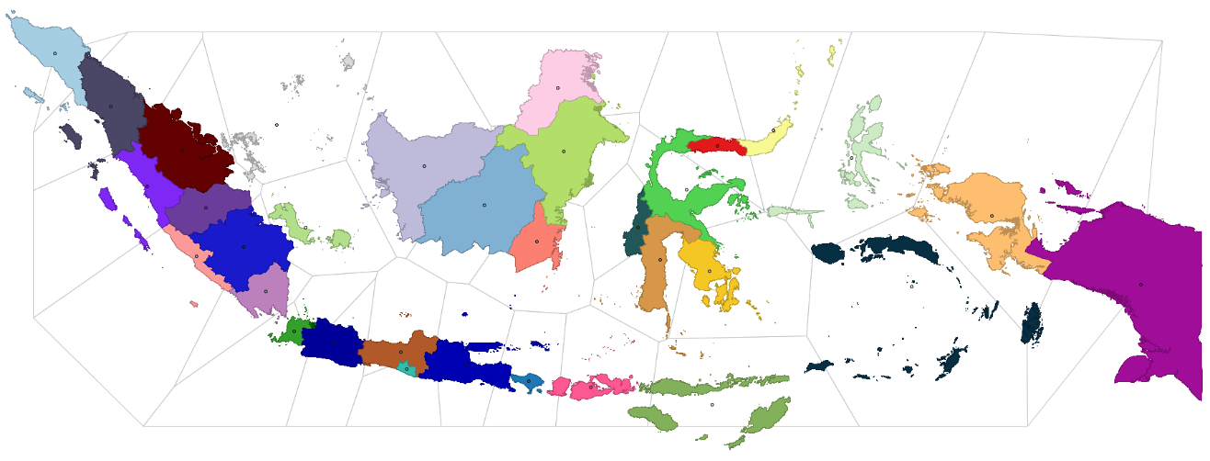

Figure 4. Indonesian provinces, centroids, and Thiessen polygons

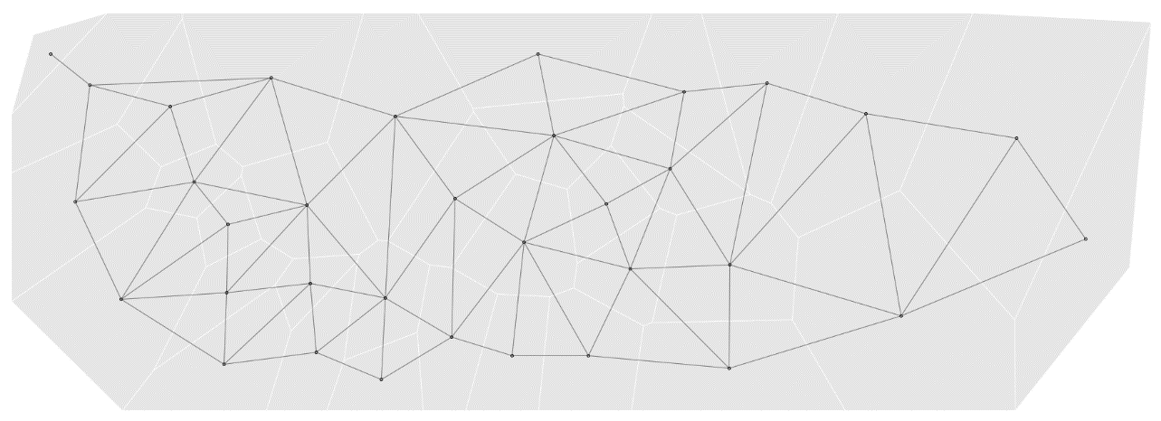

Figure 5. Centroids, Thiessen polygons, and spatial connectivity structure

1. Output gap is the gap between potential and actual output. For simplicity, we used Hodrick-Prescott (HP) filter to extract the trend of GDP data as estimate of potential output. The computed output gap is the difference between actual GDP data and its estimated trend.
2. The data shows how people to (or time spent in) categorized places change compared to baseline days. The baseline day is the median value from the 5-week period Jan 3 – Feb 6, 2020, representing a normal value for that day of the week. For further details about category of places and everything related to the data, please visit

   https://support.google. com/covid19-mobility/answer/9824897?hl=en&ref_topic=9822927.
3. We include the share of Transportation, Accommodation and Services (TAS) to GDP in addition to previous variables. In the statistics of Indonesian GDP, TAS sector includes ”Transportasi dan Pergudangan”, ”Penyediaan Akomodasi dan Makan Minum”, ”Administrasi Pemerintahan, Pertahanan dan Jaminan Sosial Wajib”, and ”Jasa Lainnya”.
4. For further exploration of COVID-19 cases and its economic impacts across provinces in Indonesia, please visit [RPubs - Covid-19 pandemic and its economic impacts in Indonesia](https://rpubs.com/haginta/covid19-econ-impacts-indonesia) and [Covid-19 pandemic and its economic impacts: An interactive exploration on Indonesian provincial data (shinyapps.io)](https://haginta.shinyapps.io/Covid19_econ_impacts_reg_Indonesia/)
5. We planned to also use unemployment data. However, the official unemployment data that capture the COVID-19 pandemic period will be released in November 2020.
6. ”High” and ”low” are in relative term to the mean of the variable, and thus can‘t be interpreted as an absolute term.
7. According to official news from Indonesian government.